**Processing Document:**

1. Go to the source of dataset on website <http://www.ers.usda.gov/data-products/county-level-data-sets.aspx>

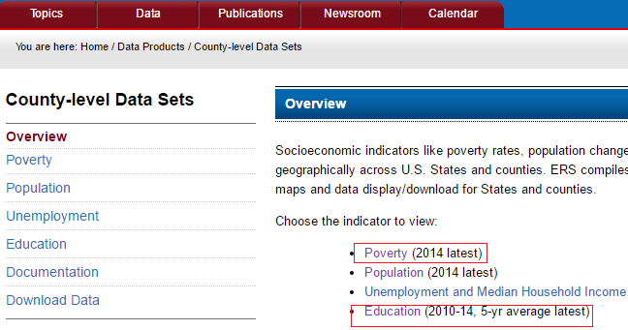

1. Extract the highlighted datasets on to the local drive in the csv format.

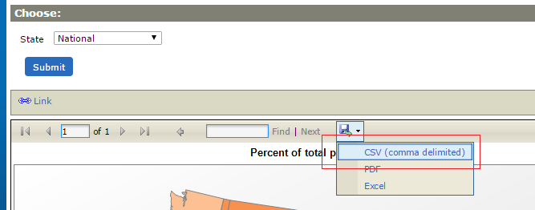

1. Open EducationReport.csv and copy columns state_National, total_est_pct2, total_est_pct_Bmin2, total_est_pct_Bmax2, under18_pct2, under18_pct_Bmin2, under18_pct_Bmax2 and paste it new CSV file.
2. Open PovertyReport.csv and copy columns rate_2011, ID2010_U, ID2010_R and paste it new CSV file.
3. “Save as” this file as Education and Poverty rate combined.csv
4. Delete the unit (percentage sign) from all the values of columns total_est_pct and rate_2011.
5. The resulting file, Education and Poverty rate combined.csv should be cited as Revalkar, P., Kurane, A. (2016, March 15). *Education and Poverty Rate combined.* [Dataset CSV file]. Retrieved from https://github.com/prasadrevalkar/INFM600/blob/master/Education%20and%20Poverty%20rate%20combined.csv. The data in the INFM600 repository is distributed under a Creative Commons Attribution-NonCommercial-ShareAlike 4.0 Internation License (see http://creativecommons.org/licenses/by-sa/4.0/).
6. For analysis, open the Education and Poverty rate combined.csv in R using read.csv command and then run the correlation on total_est_pct2 and rate_2011 columns using command cor.test(c$total_est_pct2,c$rate_2011, data=c).
7. For visual representation we plotted a general plot in R using command plot(c$total_est_pct2, c$rate_2011, xlab = "Poverty", ylab = "Education rate", main = "Poverty rate vs Education rate").

**References:**

1. United states Department of Agriculture. (2016, Feb 3). EducationReport [Dataset CSV file]. Retrieved from <http://www.ers.usda.gov/data-products/county-level-data-sets/education.aspx>. March 7, 2016.
2. United States Department of Agriculture. (2016, Feb 3). PovertyReport [Dataset CSV file]. Retrieved from <http://www.ers.usda.gov/data-products/county-level-data-sets/poverty.aspx>. March 7, 2016.
3. Revalkar, P. (2016), Kurane, A. (2016, March 15). Education and Poverty Rate combined. [Dataset CSV file]. Available from <https://github.com/prasadrevalkar/INFM600/blob/master/Education%20and%20Poverty%20rate%20combined.csv>.